Oisin test case 5

import numpy as np
import pandas as pd
import matplotlib.pyplot as plt

elif choice == 2:

x_max = 20
dx = 0.2
U = 0.1
t_max = 300
dt = 10

num_point = int(round(x_max / dx)) + 1 # calculates the number of points that x_max will have and concentration distribution will have

x_grid = np.linspace(0, x_max, num_point)
t_grid = np.arange(0, t_max + dt, dt)
conc_distribution = np.full(num_point, np.nan) # creates an arrazy with all values nan

df = pd.read_csv('/content/initial_conditions.csv', encoding='latin1') # requires latin encoding as µ was resulting in UTF-8 error when reading the file
x_csv = df.iloc[:, 0].values #locates and reads the first column knowing there is a title and to diregard it
conc_csv = df.iloc[:, 1].values # locates and reads the second column and saves them as array

for i in range(len(x_csv)):
grid_location =int( x_csv[i] / dx) # calculates the index in that we will save our concentration to

if 0 <= grid_location < num_point: # check to see data falls in our model grid and only allowing value assignement if the index exists
conc_distribution[grid_location] = conc_csv[i] # fills in the concentration location that corresponds to the location where it is stated in csv file

conc_series = pd.Series(conc_distribution) # converting the array in to a series to allow for panda operation to be done
conc_distribution = conc_series.interpolate(method='linear', limit_direction='both').values # applying linear interpolation between the values where nan lies between them. as we set interpolation direction to both.

print("data has successfully been interpolated.")

Oisin Test case 5 –

in this case we will also use the parameters x_max = 20m, spacial resolution Δx = 0.2m, Model time = 300s, temporal resolution Δt=1s, flow velocity U=0.1m s−1, concentration μg m−^3 250 at x=0, (0 elsewhere) but now with and variable stream velocity with perturbation = 0.1 ie 10% randomness.

Terminal:

This is a simulation calculator for the evolution of a pollutant concentration in a river

information needed for calculation: (ensure all inputs are +ve and non-zero)

choose simulation initialization:

test case 1 : where x_max = 20m, spacial resolution Δx = 0.2m, Model time = 300s, temporal resolution Δt=10s, flow velocity U=0.1m s−1, concentration μg m−^3 250 at x=0, 0 elsewhere)

test case 2 : initialise data for x_max, Δx and concentration distribution is read from initial_conditions.csv, with Model time = 300s, temporal resolution Δt=10s, flow velocity U=0.1m s−1

test case 3 : manual inputs

choose simulation initialization:

which test do you wish to run?3

what is the width of the model space (m) must be integer, x_max:20

Enter the space increment value (spatial resolution) (m), dx:0.2

Enter the model run time (s) must be integer, t_max:300

Enter the temporal resolution (s), dt:1

Enter the mean advective velocity (ms^-1), U:0.1

what is the start concentration at point x = 0:250

what is the start concentration at point x = 1:0

what is the start concentration at point x = 2:0

what is the start concentration at point x = 3:0

what is the start concentration at point x = 4:0

what is the start concentration at point x = 5:0

what is the start concentration at point x = 6:0

what is the start concentration at point x = 7:0

what is the start concentration at point x = 8:0

what is the start concentration at point x = 9:0

what is the start concentration at point x = 10:0

what is the start concentration at point x = 11:0

what is the start concentration at point x = 12:0

what is the start concentration at point x = 13:0

what is the start concentration at point x = 14:0

what is the start concentration at point x = 15:0

what is the start concentration at point x = 16:0

what is the start concentration at point x = 17:0

what is the start concentration at point x = 18:0

what is the start concentration at point x = 19:0

concentration distribution :

[250. 0. 0. 0. 0. 0. 0. 0. 0. 0. 0. 0. 0. 0.

0. 0. 0. 0. 0. 0. 0. 0. 0. 0. 0. 0. 0. 0.

0. 0. 0. 0. 0. 0. 0. 0. 0. 0. 0. 0. 0. 0.

0. 0. 0. 0. 0. 0. 0. 0. 0. 0. 0. 0. 0. 0.

0. 0. 0. 0. 0. 0. 0. 0. 0. 0. 0. 0. 0. 0.

0. 0. 0. 0. 0. 0. 0. 0. 0. 0. 0. 0. 0. 0.

0. 0. 0. 0. 0. 0. 0. 0. 0. 0. 0. 0. 0. 0.

0. 0. 0.]

model space:

[ 0. 0.2 0.4 0.6 0.8 1. 1.2 1.4 1.6 1.8 2. 2.2 2.4 2.6

2.8 3. 3.2 3.4 3.6 3.8 4. 4.2 4.4 4.6 4.8 5. 5.2 5.4

5.6 5.8 6. 6.2 6.4 6.6 6.8 7. 7.2 7.4 7.6 7.8 8. 8.2

8.4 8.6 8.8 9. 9.2 9.4 9.6 9.8 10. 10.2 10.4 10.6 10.8 11.

11.2 11.4 11.6 11.8 12. 12.2 12.4 12.6 12.8 13. 13.2 13.4 13.6 13.8

14. 14.2 14.4 14.6 14.8 15. 15.2 15.4 15.6 15.8 16. 16.2 16.4 16.6

16.8 17. 17.2 17.4 17.6 17.8 18. 18.2 18.4 18.6 18.8 19. 19.2 19.4

19.6 19.8 20. ]

model time:

300

choose initialization for calculation

calculator 1 (for questions 1,2,3) : regular advection calculation done

calculator 2 (for questions 4) : advection calculation modelled with exponential decay of concentration with time

calculator 3 (for questions 5) : advection calculation with variable velocity profile

which test do you wish to run?3

we will use the advection equation: ∂C/∂t + U(x,t) ∂C/∂x = 0

enter the random perturbation factor (0 to 0.5)?0.1

courant number max: 0.5475675012487378

u_grid : [0.1095135 0.10557464 0.10743231 0.092348 0.10057846 0.10428095

0.10908539 0.10362448 0.10542232 0.10331973 0.10010696 0.09225979

0.0970285 0.09093875 0.09555023 0.10058485 0.09175933 0.10550202

0.10428426 0.10933338 0.09794373 0.09823438 0.10361222 0.09875332

0.09958324 0.09800746 0.10657072 0.09679238 0.10492033 0.09763924

0.09627999 0.10279556 0.09778375 0.09557397 0.10311573 0.09935432

0.10055098 0.09169951 0.0925916 0.09666017 0.09341939 0.10134043

0.10248778 0.10727197 0.0940432 0.09287737 0.09398991 0.10373963

0.10524897 0.10170494 0.09558413 0.09138572 0.09207896 0.10270775

0.09143854 0.10190668 0.10322847 0.10510618 0.0993796 0.10341241

0.09196899 0.10188794 0.09727712 0.1009416 0.09173496 0.09049476

0.10289834 0.10514197 0.10585298 0.09532113 0.09539409 0.10000716

0.10068847 0.09582897 0.09933055 0.10467864 0.10073127 0.10904512

0.09184014 0.10291704 0.09752409 0.09876408 0.10618622 0.0906201

0.10333002 0.10793933 0.09787292 0.0938242 0.09698681 0.09300459

0.09637668 0.09446661 0.10636534 0.10235853 0.09809268 0.09340472

0.10419527 0.09315014 0.09195739 0.10395758 0.09343068]

calculated result:

[[2.50000000e+02 0.00000000e+00 0.00000000e+00 ... 0.00000000e+00

0.00000000e+00 0.00000000e+00]

[0.00000000e+00 1.31968298e+02 0.00000000e+00 ... 0.00000000e+00

0.00000000e+00 0.00000000e+00]

[0.00000000e+00 6.23057713e+01 7.08882980e+01 ... 0.00000000e+00

0.00000000e+00 0.00000000e+00]

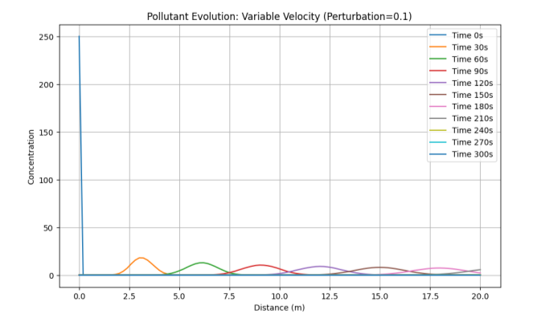

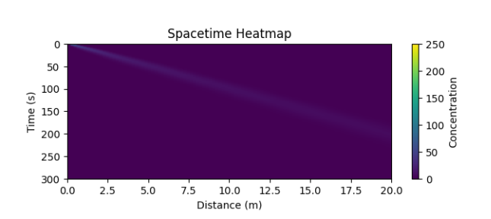

We see little change in the graph from the calculation without perturbation. This is because the perturbation is small an so

